Q1:
A1:
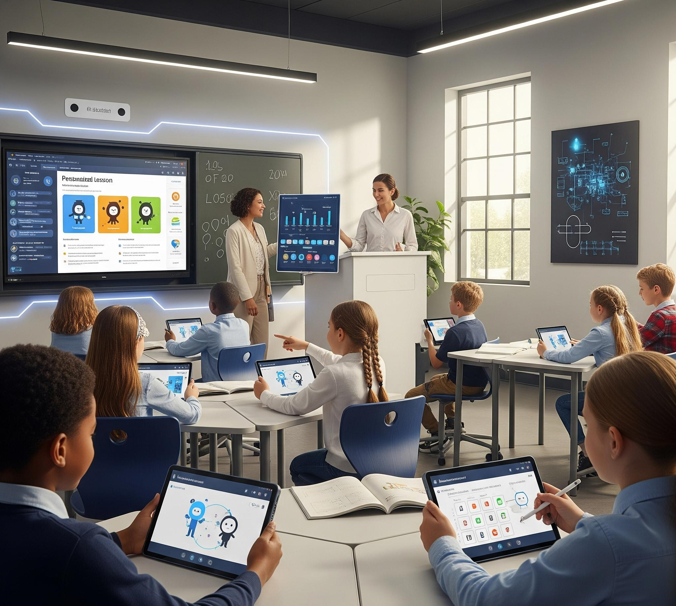
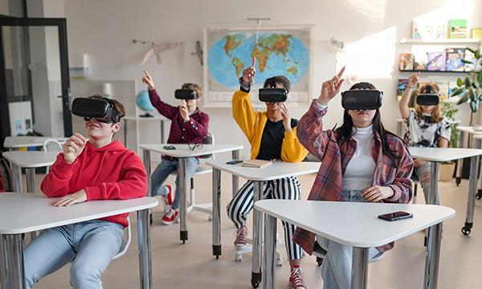
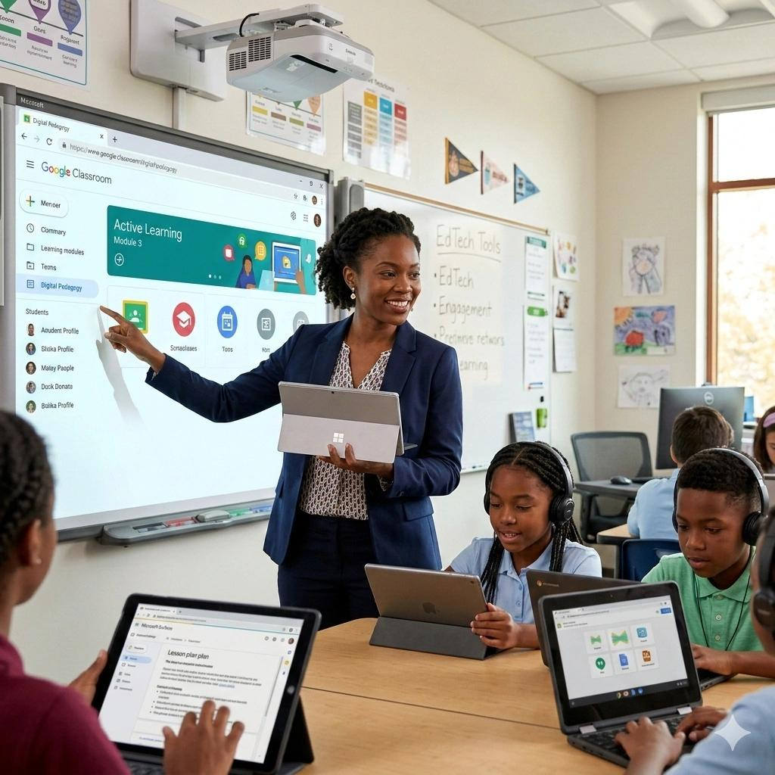
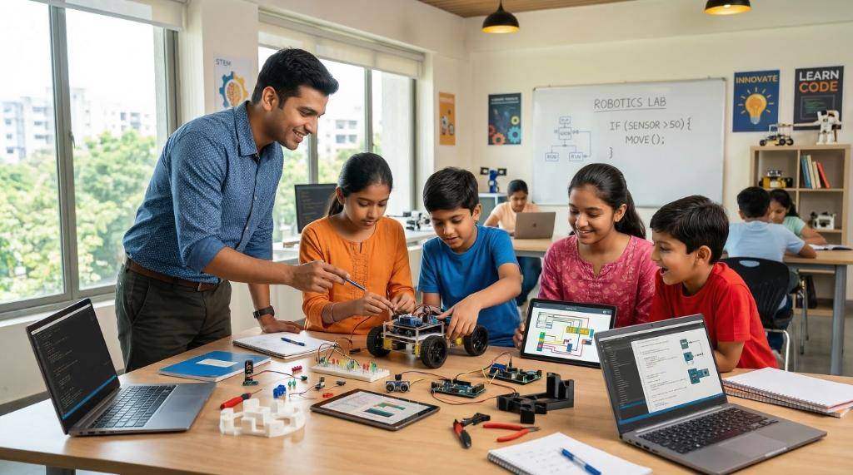
Education in developed countries is undergoing a major transformation. The traditional model:
Teacher → textbook → classroom → exam → university → job
is changing into:
AI + teacher + personalized learning + skills + lifelong learning + real-world projects
The biggest trends are below.

1. AI-Powered Education (the biggest trend)

Current direction
Developed countries are rapidly integrating:
- AI tutors
- AI teaching assistants
- AI grading systems
- AI curriculum generators
- AI student analytics
- AI language learning systems
The OECD highlights that generative AI is becoming a major factor in education, but emphasizes that success depends on using AI with strong teaching principles rather than simply adding technology. (OECD)

Examples

AI Personal Tutor
Instead of every student receiving the same lesson:
Traditional:
Teacher
|
|
Same lesson
|
100 students
Future:
AI Learning Engine

Student A → Math level 5 → Algebra exercises
Student B → Math level 3 → Basic calculation
Student C → Math level 8 → Advanced problems
AI analyzes:
- mistakes
- learning speed
- interests
- weak areas
- memory retention
and creates a personal learning path.

AI Teacher Assistant
Teachers use AI for:

Before class
AI creates:
- lesson plans
- quizzes
- homework
- presentations
- examples

During class
AI provides:
- real-time student understanding
- difficulty adjustment
- translation

After class
AI creates:
- reports
- student progress analysis
- parent communication

2. Smart Schools / AI Campus
Many developed countries are moving toward smart schools.
A smart school combines:

Infrastructure
Smart School Platform

|
|
------------------------
| | |
AI Engine LMS Database
| | |
Students Teachers Administrators
Components:

Student Management System
Stores:
- grades
- attendance
- behavior
- learning history

Learning Management System (LMS)
Examples:
- Moodle
- Canvas
- Google Classroom
- Blackboard
Used for:
- online courses
- homework
- exams
- materials

AI Knowledge Engine
A school-specific ChatGPT:
Example:
Student asks:
"How do I solve this physics question?"
AI answers using:
- school textbooks
- teacher explanations
- previous exams
- school knowledge base
This is especially important for schools without reliable internet.

3. Personalized Learning
The old system:
Age 12 students
|
same textbook
|
same exam
Future:
Student Profile

- Math ability
- Language ability
- Learning speed
- Interests
- Career goal

↓

Personal Curriculum
Students learn at different speeds.

Countries leading this:

Singapore
Focus:
- mastery learning
- AI-assisted teaching
- data-driven education

China
Focus:
- digital textbooks
- AI learning assistants

Finland
Focus:
- student autonomy
- creativity
- problem-solving

4. From Memorization to Skills
Developed countries are reducing pure memorization.
Old:
Remember information
↓
Take exam
↓
Forget
New:
Understand
↓
Apply
↓
Create
↓
Solve problems
Important skills:

Digital skills
- programming
- AI usage
- data analysis
- cybersecurity

Human skills
- communication
- teamwork
- creativity
- critical thinking
The OECD Future of Education and Skills 2030/2040 project focuses on student agency, competencies, well-being, and preparing students for future societies. (OECD)

5. Coding and AI Education from Early Age
Many developed countries introduce:

Primary school
Age 6-12:
- computational thinking
- robotics
- basic programming
Examples:
- Scratch
- LEGO robotics

Secondary school
Students learn:
- Python
- AI concepts
- data science
- cybersecurity

University
Focus shifts toward:
- AI engineering
- machine learning
- robotics
- biotechnology

6. Virtual Reality (VR) and Augmented Reality (AR)
Education is moving from:
"read about something"
to
"experience something"
Examples:

Biology
Traditional:
Book picture of human heart
Future:
VR human body exploration

History
Traditional:
Read about Ancient Rome
Future:
Walk inside Ancient Rome using VR

Engineering
Students can practice:
- factories
- laboratories
- dangerous environments
without risk.

7. Online + Offline Hybrid Education
COVID accelerated this trend.
Future education:
School Classroom
+
Online Platform
+
AI Tutor
+
Self-learning
Students may:
Morning:
- classroom
Afternoon:
- AI-guided study
Evening:
- online courses

8. Lifelong Learning
A major change:
Education is no longer:
Study until 22 years old
|
|
Work forever
New model:
Learn
↓
Work
↓
Learn new skills
↓
Change career
↓
Learn again
Because AI changes jobs quickly.
Popular platforms:
- Coursera
- edX
- Udemy
- LinkedIn Learning

9. AI-Based Student Prediction Analytics
Schools increasingly analyze:
- grades
- attendance
- learning behavior
to predict:
- dropout risk
- future performance
- required support
Example:
AI detects:
Student:
Math score ↓
Homework ↓
Attendance ↓

Risk:
High probability of failure

Action:
Teacher intervention

10. Automated Assessment
Traditional:
Teacher manually grades:
100 students
x
10 assignments
Very time-consuming.
Future:
AI evaluates:
- essays
- coding
- presentations
- language speaking
with teacher supervision.

11. Education Data Platforms
Modern schools need large data systems.
Typical architecture:
Smart Education Platform

AI Engine
|
|
------------------------------------------------
| | | |
Student DB Learning DB Exam DB Behavior DB

|
|
Analytics Engine

|
Teacher / Parent Dashboard

12. Robotics Education
Growing quickly.
Students learn:
- robotics
- automation
- engineering
Examples:
- robot competitions
- AI robot assistants
- industrial simulation
Countries investing heavily:
- Japan
- Germany
- China
- Singapore

13. Language Learning AI
A huge market.
Future language learning:
AI conversation partner:
Student speaks English

↓

AI analyzes:

- pronunciation
- grammar
- vocabulary
- fluency

↓

Personal correction
Advantages:
- 24/7 availability
- unlimited practice
- native-like conversation

14. Teacher Role Is Changing
Teachers are not disappearing.
Their role changes:
Before:
Teacher = Information Provider
Future:
Teacher = Mentor + Coach + Learning Designer
AI handles:
- repetitive tasks
- administration
- basic explanations
Teacher focuses on:
- motivation
- creativity
- emotional support

15. Biggest Problems Developed Countries Face
Despite technology, there are serious challenges.

1. Learning decline
Several developed education systems have experienced declines in reading, mathematics, and science performance after the pandemic period. Analysts have pointed to factors including learning disruption, teacher shortages, inequality, and digital distraction. (The Guardian)

2. Teacher shortage
Countries face:
- aging teachers
- burnout
- difficulty recruiting

3. AI cheating
Problems:
- students asking AI to write homework
- reduced independent thinking
The current debate is shifting from "ban AI" toward "teach responsible AI usage." (CIDDL)

4. Digital inequality
Some students have:
- fast internet
- computers
- AI tools
Others do not.

16. Future Education Market Opportunities
The fastest-growing areas are likely:

AI Education Platforms
Examples:
- AI tutors
- AI exam preparation
- AI homework assistants

Smart School Systems
Products:
- school ERP
- LMS
- AI knowledge base
- student analytics

Offline AI Education
Very important for:
- rural areas
- developing countries
- schools without internet

Teacher AI Tools
Examples:
- lesson generation
- automatic grading
- curriculum design

Language AI
Especially:
- English learning
- pronunciation
- conversation

17. If Building a Smart School AI System Today
A modern architecture would look like:
Smart School AI Platform

AI Layer
---------------------------------
| LLM | RAG | Speech AI | Vision |
---------------------------------

|
|

Knowledge Database

-----------------------------
| Textbooks |
| Exams |
| Teacher Answers |
| Student Records |
-----------------------------

|

School Applications

-----------------------------------------
| Student App | Teacher App | Parent App |
-----------------------------------------

|

Infrastructure

-----------------------------------------
| Servers | Storage | Network | Security |
-----------------------------------------

Summary: The Top 10 Education Trends
Rank | Trend
1 | AI tutors and AI teachers
2 | Personalized learning
3 | Smart schools
4 | AI student analytics
5 | Hybrid online/offline learning
6 | Skills-based education
7 | Coding and AI from young age
8 | VR/AR immersive learning
9 | Lifelong learning
10 | Local/private AI education systems
For the smart school AI engine project you mentioned earlier, the strongest global direction is combining:
Local LLM + RAG knowledge base + student analytics + LMS + teacher assistant + offline AI server
This is very close to where advanced education systems are moving. (unesco.org)

Q2: Thanks. What is the benefit of this new AI based education?
A2:
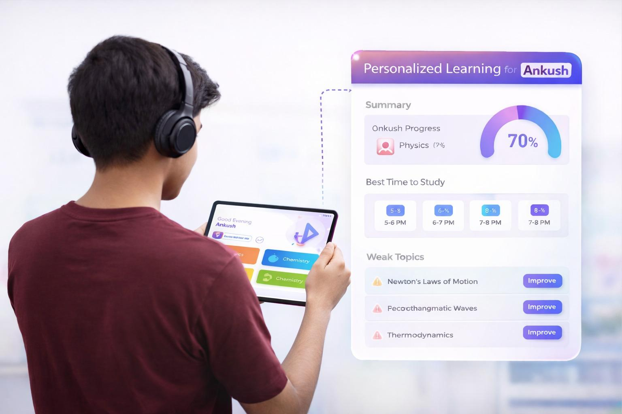

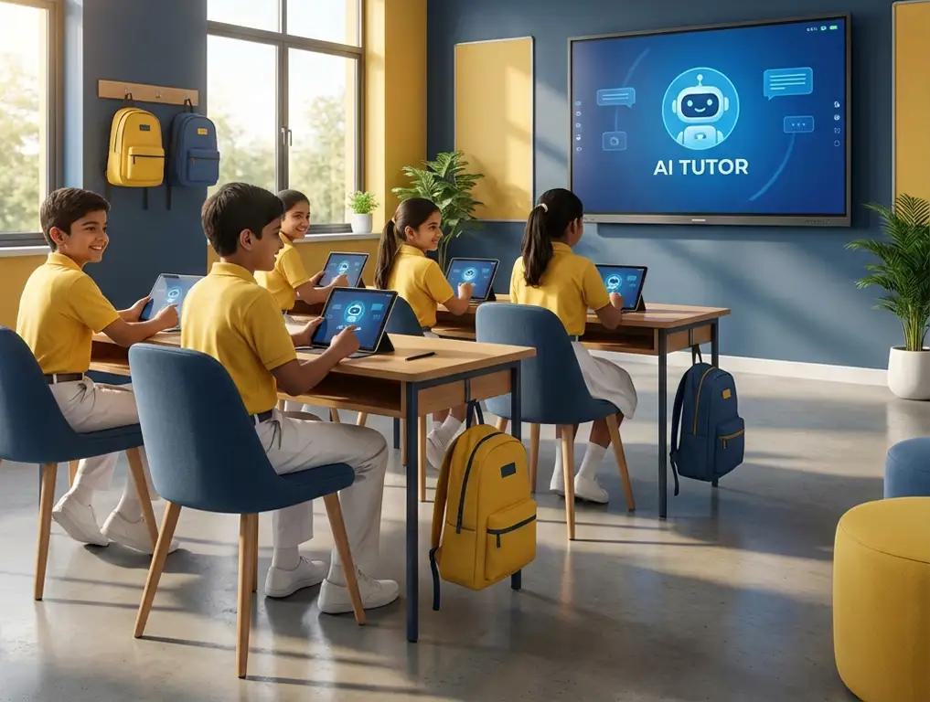
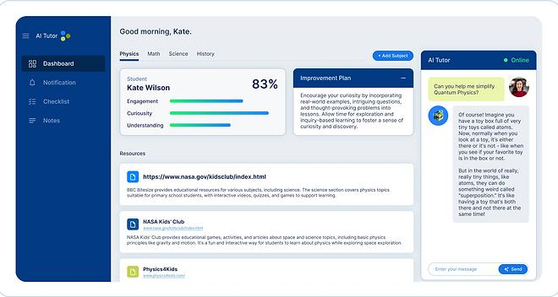
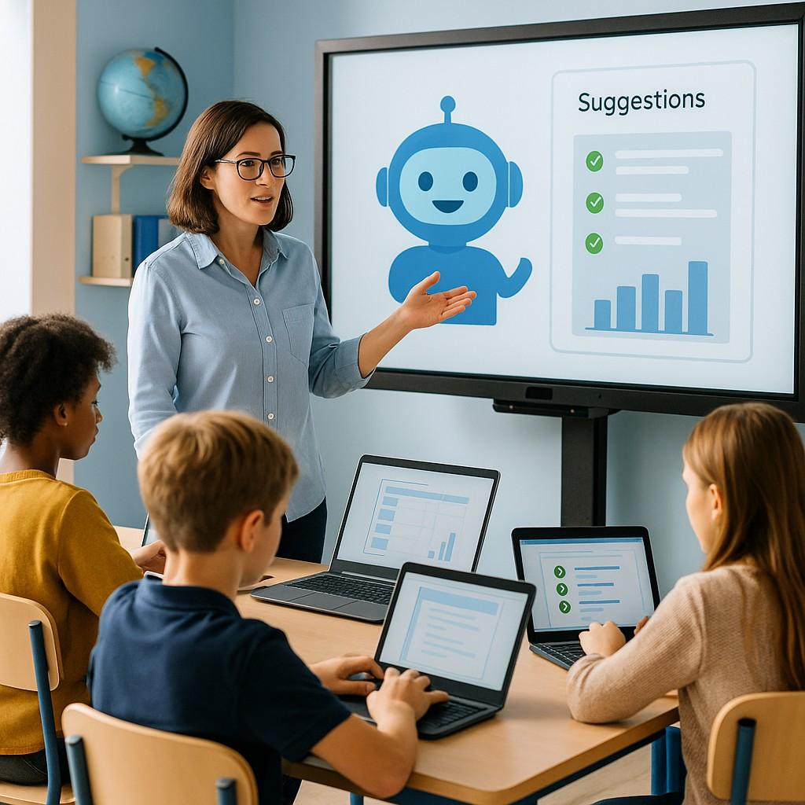
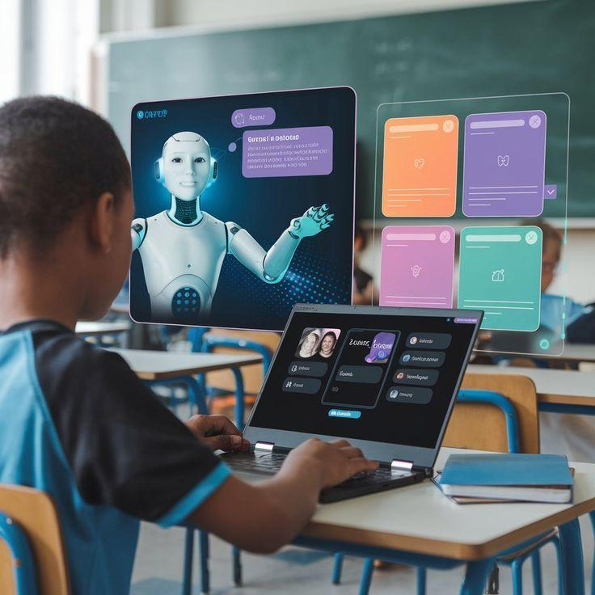
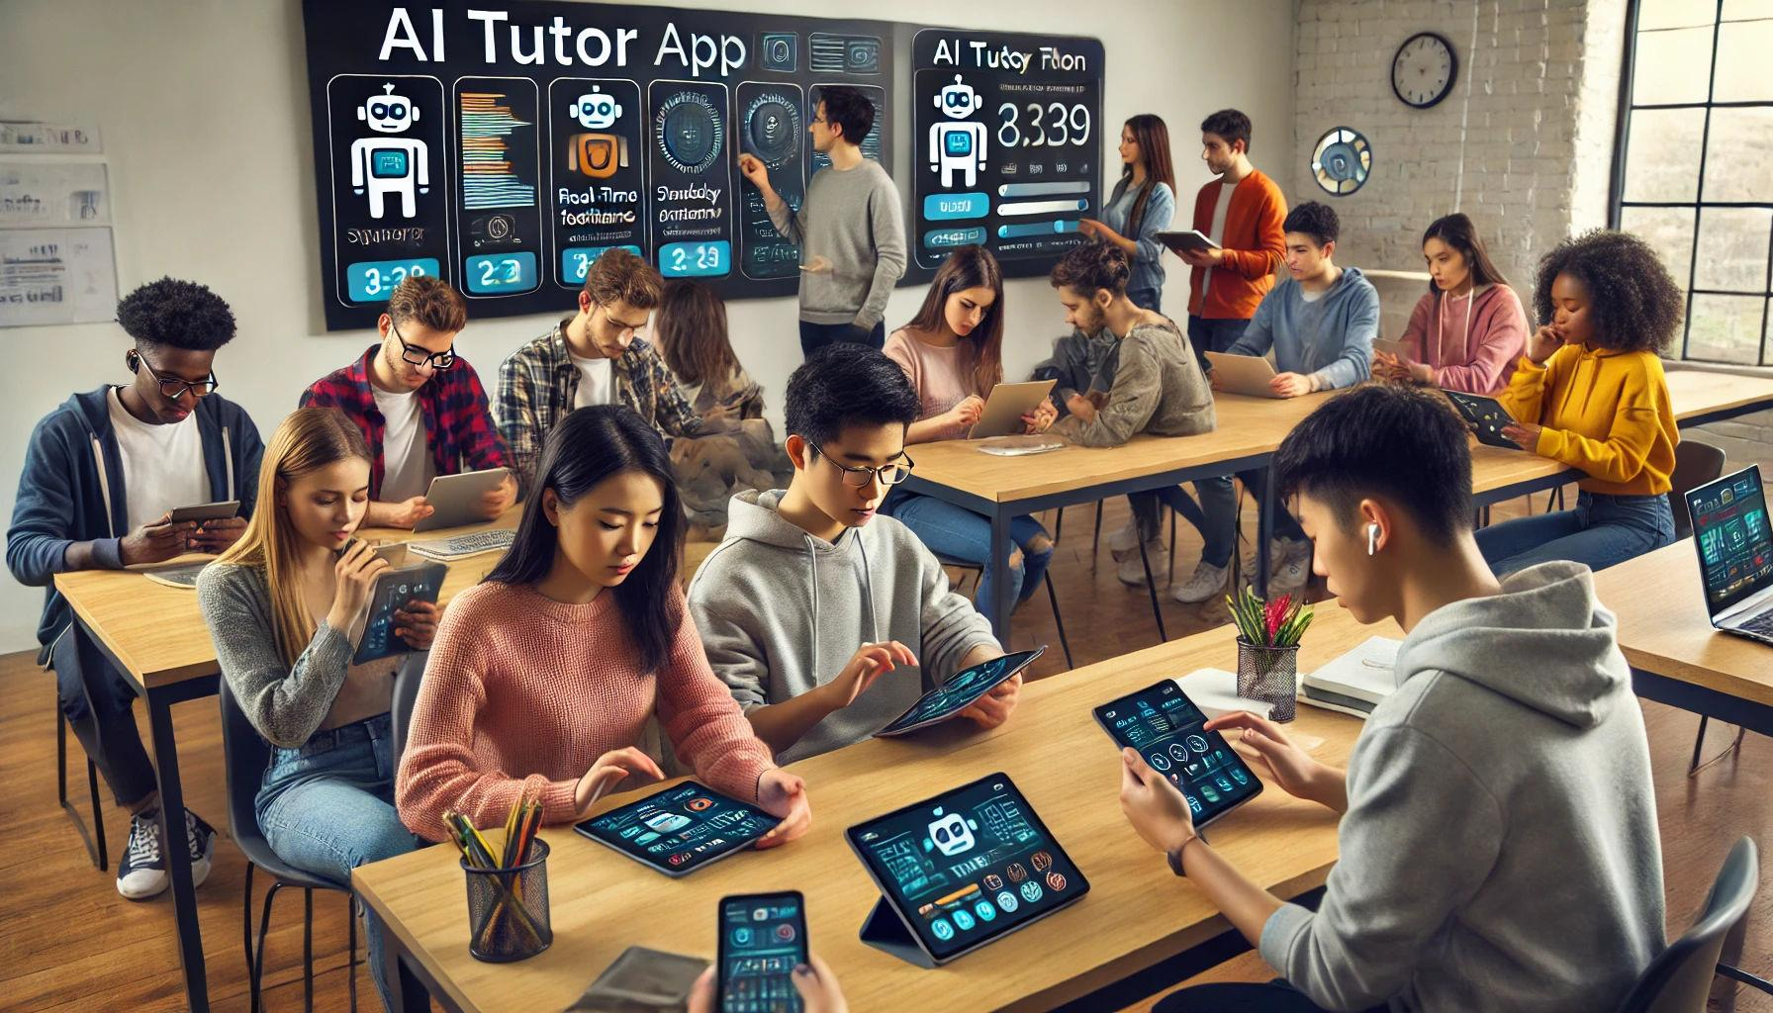
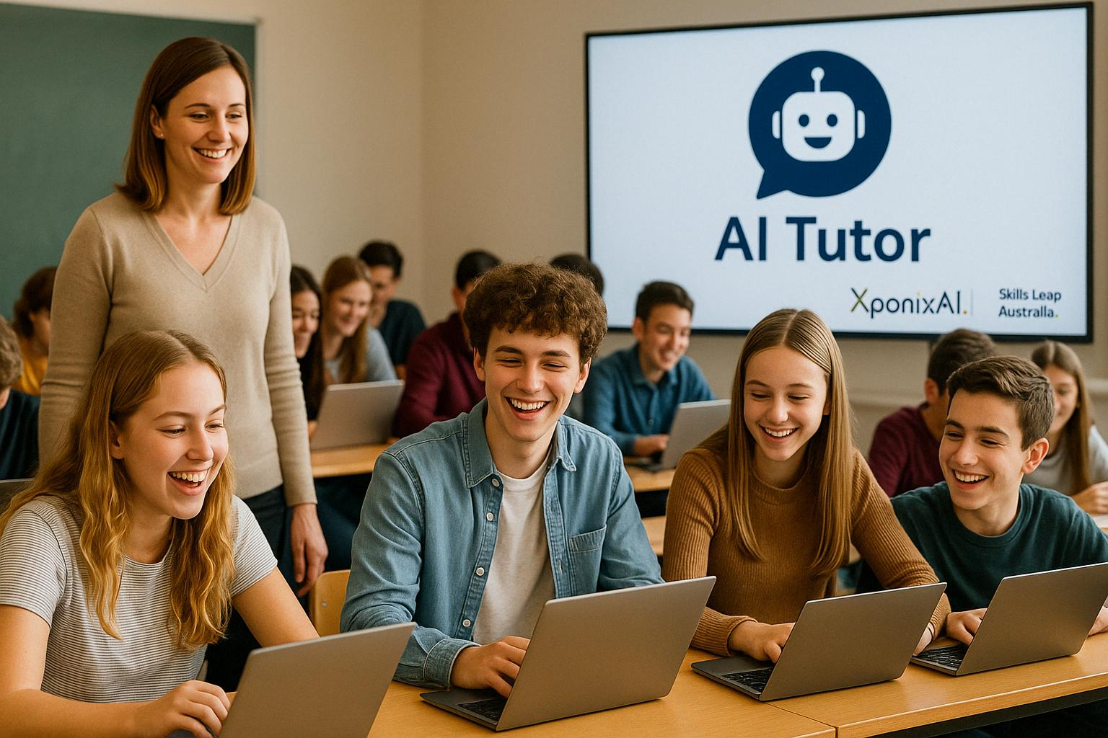
The benefit of AI-based education is not simply "using AI in schools." The real change is that education can become personalized, measurable, scalable, and available everywhere.
The biggest benefits are below.

1. Every Student Gets a Personal Teacher (Personalized Learning)

Traditional education
A teacher teaches 30–40 students:
Teacher
|
Same lesson
|
40 students
Problem:
- Some students are bored because it is too easy.
- Some students fall behind because it is too difficult.

AI education
Each student receives a customized learning path:
AI Tutor

Student A → Beginner math exercises
Student B → Advanced math problems
Student C → Extra explanation + practice
AI can analyze:
- current ability
- mistakes
- learning speed
- interests
- weak points

Benefit:
A weak student can catch up.
A strong student can move faster.

2. 24/7 Learning Support
A human teacher cannot answer questions all day.
AI can:
- explain concepts
- answer questions
- provide examples
- correct mistakes
Example:
A student studies at 11 PM:
"I don't understand quadratic equations."
AI immediately explains:
- simple explanation
- examples
- practice questions

Benefit:
Learning is no longer limited by school hours.

3. Reduces Teacher Workload
Teachers spend a lot of time on repetitive tasks.
Examples:
Before AI:
Teacher:

Prepare lesson 5 hours
Create tests 3 hours
Grade homework 10 hours
Write reports 5 hours

Total: 23 hours
With AI:
AI:

Generate lesson
Generate quizzes
Assist grading
Create reports

Teacher focuses on students

Benefit:
Teachers spend more time on:
- mentoring
- discussion
- creativity
- emotional support

4. Early Detection of Student Problems
AI can identify problems earlier.
Example:
AI notices:
Student:

Math score:
90 → 80 → 65

Homework:
100% → 60% → 20%

Attendance:
Good → declining
AI predicts:
"This student may need support."
Teacher can intervene early.

Benefit:
Prevent failure instead of fixing failure later.

5. Better Learning Results
AI provides:

Immediate feedback
Traditional:
Student submits homework

↓

Teacher checks after 3 days

↓

Student forgot the mistake
AI:
Student answers

↓

AI checks immediately

↓

Student learns immediately
Educational research generally finds that timely feedback improves learning effectiveness.

6. Equal Education Opportunities
One of the biggest advantages.
A rich student:
- expensive tutor
- private lessons
A poor student:
- only school resources
AI can provide:
Powerful AI tutor
+
School knowledge base
+
Learning materials
at much lower cost.

Benefit:
Students in:
- rural areas
- developing countries
- remote schools
can access high-quality learning support.

7. Language Learning Becomes Much Easier
Traditional English learning:
Student
|
Textbook
|
Grammar exercises
AI language learning:
Student speaks

↓

AI analyzes:

Pronunciation
Grammar
Vocabulary
Fluency

↓

Correction
Benefits:
- unlimited conversation practice
- instant pronunciation feedback
- personalized vocabulary

8. Better Understanding of Each Student
AI creates a student learning profile.
Example:
Student Profile:

Math:
85%

English:
60%

Reading:
90%

Programming:
95%

Learning style:
Visual

Weakness:
Grammar
Teachers can understand students much better.

9. More Practical Learning
AI allows students to learn by doing.
Examples:

Engineering student
Instead of reading:
"How does an engine work?"
AI creates:
- simulation
- virtual laboratory
- interactive model

Medical student
AI creates:
- patient simulations
- diagnosis practice

10. Continuous Improvement of Education
A school can analyze:
Thousands of students

↓

AI finds patterns

↓

Improve teaching methods
Example:
AI discovers:
"Students who practice vocabulary 15 minutes daily improve 30% faster."
School adjusts curriculum.

11. Local AI Knowledge Base (Very Important for Schools)
For a school, AI can learn from:
- textbooks
- previous exams
- teacher answers
- school rules
- curriculum
Example:
Student asks:
"How do I solve this physics problem?"
AI searches:
School database

+
Teacher explanations

+
Previous solutions

↓

Answer
This creates a school-specific AI tutor.

12. Benefits for Parents
Parents can see:
Child Progress Dashboard

Math:
↑ improving

English:
↓ needs support

Study time:
8 hours/week

Recommended:
Practice vocabulary
Parents do not need to wait for monthly meetings.

13. Benefits for Governments
For national education systems:
AI can analyze:
- education quality
- regional differences
- teacher needs
- student performance
It helps governments make better decisions.

Comparison: Traditional vs AI Education
Area | Traditional | AI-Based
Teaching | Same lesson for everyone | Personalized
Teacher workload | Very high | Reduced
Feedback | Slow | Immediate
Learning time | School hours | 24/7
Student tracking | Limited | Continuous
Tutor access | Expensive | Available
Content | Fixed textbook | Dynamic
Language learning | Classroom only | AI conversation
Remote areas | Difficult | Much easier

However, AI Education Does NOT Replace Teachers
The likely future model is:
Teacher + AI

Teacher:
- motivation
- human relationship
- creativity
- guidance

AI:
- knowledge
- analysis
- practice
- personalization
The teacher becomes more powerful.

For a Smart School Project
The biggest commercial value is probably:

Student AI Tutor

Teacher AI Assistant

School Knowledge Base

Student Performance Prediction

Offline AI Server
This combination can transform a normal school into a smart AI-powered campus.
For countries or regions with limited internet access, an on-premise AI education server is especially valuable because the school owns the knowledge base and can run the AI locally.

Q3: What is the disadvantage of this education?
A3:

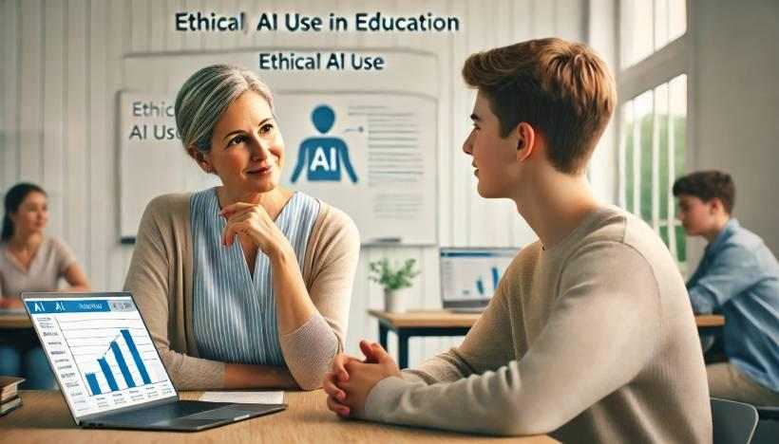
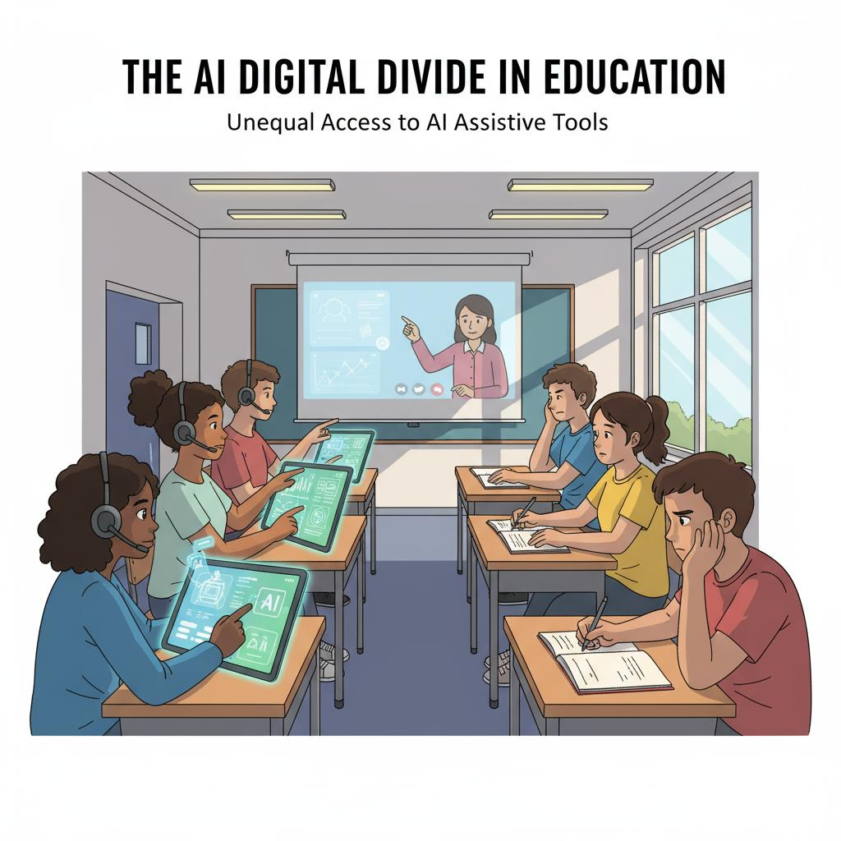

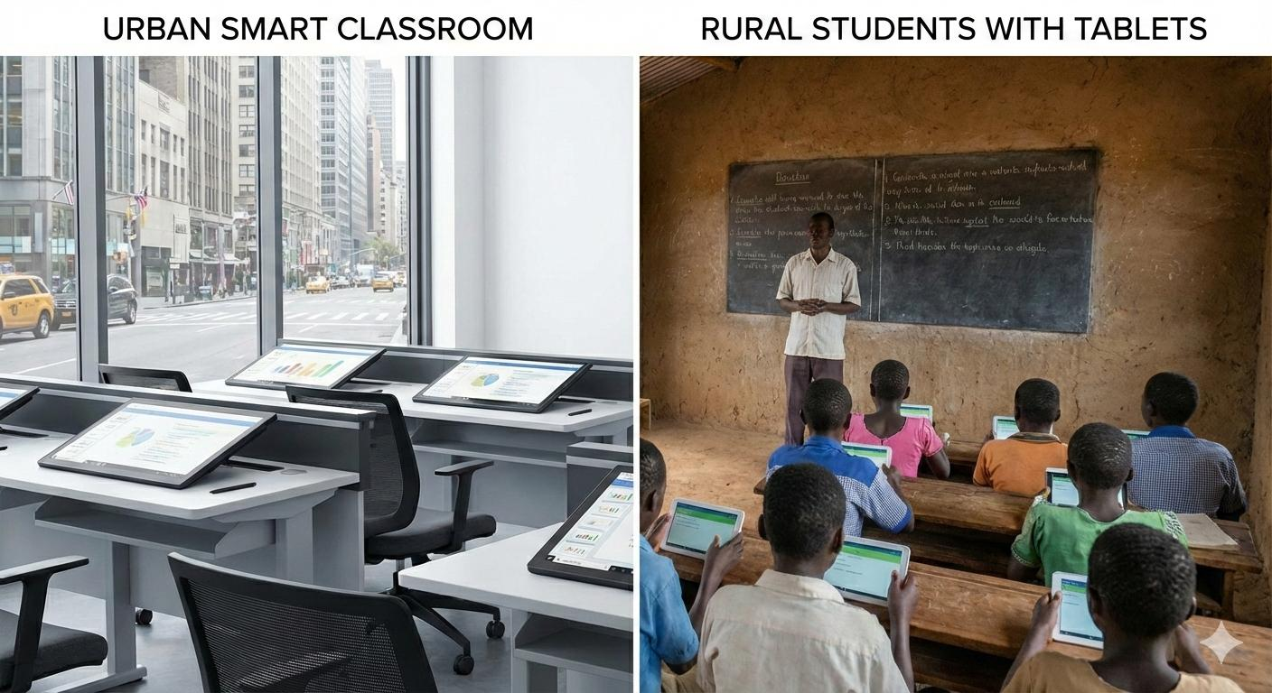
AI-based education has many advantages, but it also creates new risks and challenges. Developed countries are actively discussing these issues because the goal is not only to make education more efficient, but also to protect students' development.
The major disadvantages are below.

1. Students May Become Too Dependent on AI
This is probably the biggest concern.
Example:
A student has homework:
"Explain why climate change happens."
Traditional learning:
Student researches
↓
Student thinks
↓
Student writes answer
AI-based learning:
Student asks AI
↓
AI writes answer
↓
Student copies
Problem:
Students may lose:
- critical thinking
- problem-solving ability
- creativity
- independent learning skills
The danger is:
Students know how to get answers but do not know how to think.

2. Reduced Human Interaction
Education is not only about information.
Students also learn:
- communication
- teamwork
- empathy
- leadership
- social skills
If students spend too much time with AI:
Student
|
|
AI
instead of:
Student
|
Teacher + classmates
they may have fewer opportunities to develop interpersonal skills.

3. AI Can Give Wrong Answers
AI is powerful but not perfect.
Problems:
- incorrect information
- outdated information
- misunderstanding questions
- generating false explanations
Example:
A student asks:
"Why did this historical event happen?"
AI may produce a convincing but inaccurate explanation.
Therefore:
Students and teachers still need:
- verification skills
- critical thinking

4. Privacy and Student Data Risks
AI education requires collecting a lot of data:
Examples:
- grades
- behavior
- learning speed
- mistakes
- interests
- voice recordings
- facial expressions (some systems)
Potential risks:
Student Data
|
|
AI Platform
|
|
Privacy Risk
Questions:
- Who owns the data?
- Who can access it?
- How long is it stored?
- Can it affect the student's future?

5. Bias in AI Systems
AI learns from data.
If training data has problems, AI may produce biased results.
Example:
AI predicts:
"This student may not succeed in advanced mathematics."
Possible issue:
The prediction may reflect:
- historical inequality
- incomplete data
- incorrect assumptions
AI should assist teachers, not make final decisions alone.

6. Digital Divide
AI education requires:
- computers
- servers
- internet
- electricity
- technical support
Rich schools:
Modern computers
+
AI servers
+
Fast internet
Poor schools:
Old computers
+
Limited internet
This may increase inequality.

7. High Implementation Cost
A complete AI education system requires:

Hardware
- servers
- storage
- networking
- devices

Software
- AI models
- LMS
- security systems

People
- IT engineers
- teachers training
- administrators
Small schools may struggle with the cost.

8. Teachers Need New Skills
Many teachers were trained for traditional education.
They now need to learn:
- AI tools
- digital teaching methods
- data interpretation
Possible problem:
Some teachers may feel:
"AI is replacing my job."
Actually, the more realistic change is:
Teacher role changes from:
Information provider
to:
Learning designer + mentor
But training is necessary.

9. Students May Lose Patience
AI gives instant answers.
A possible problem:
Students become used to:
Question
↓
Instant answer
Real life often requires:
Problem
↓
Research
↓
Failure
↓
Experiment
↓
Solution
Learning patience and persistence is important.

10. Reduced Creativity
If students always ask AI:
"Give me an idea."
they may stop generating their own ideas.
Example:
Writing:
Bad use:
AI writes the entire essay
Student submits
Good use:
Student writes first draft
AI gives feedback
Student improves
The difference is how AI is used.

11. Assessment Becomes More Difficult
Traditional exams:
Student writes answer
Teacher evaluates
With AI:
Student + AI
|
|
Who produced the answer?
Schools need new evaluation methods:
- oral exams
- projects
- presentations
- practical tasks

12. Technical Problems
A school depending heavily on AI may face:
- server failures
- network problems
- software bugs
- cyber attacks
Example:
If the AI server is down:
Teacher cannot access lesson plans
Students cannot access tutor
Therefore, backup systems are needed.

13. Cybersecurity Risks
Education systems contain valuable information.
Attack targets:
- student records
- exams
- personal information
- school documents
A smart school needs:
- encryption
- access control
- backups
- monitoring

14. Less Traditional Learning Habits
Some experts worry that AI may reduce:
- handwriting practice
- memorization ability
- reading long texts
- deep concentration
For example:
Reading a 300-page book develops different skills than asking AI for a summary.

15. AI May Not Understand Emotions Like Humans
A teacher can notice:
"This student is quiet today. Something is wrong."
AI may only see:
Score decreased
Homework missing
Attendance lower
Human understanding is still important.

Summary Table
Disadvantage | Risk Level
AI dependency | Very High
Loss of critical thinking | Very High
Privacy problems | Very High
Wrong AI answers | High
Teacher adaptation | High
Cost | Medium-High
Digital inequality | High
Reduced human interaction | Medium
Cybersecurity | High
Creativity reduction | Medium

The Best Future Model
The most successful education systems will probably not replace teachers with AI.
The model will be:
Smart Education

AI
|
----------------------------
| |
Teacher Student
| |
Human guidance Personalized learning
|
Creativity + Motivation
The key principle:
AI should amplify teachers and students, not replace human thinking.
For a smart school AI project, these disadvantages are actually important design requirements. A good system should include:
- teacher approval before AI decisions
- private local AI servers
- transparent AI explanations
- student data protection
- AI literacy training
Those features will become competitive advantages in future education systems.

Q4:How can we overcome this disadvantage then?
A4:
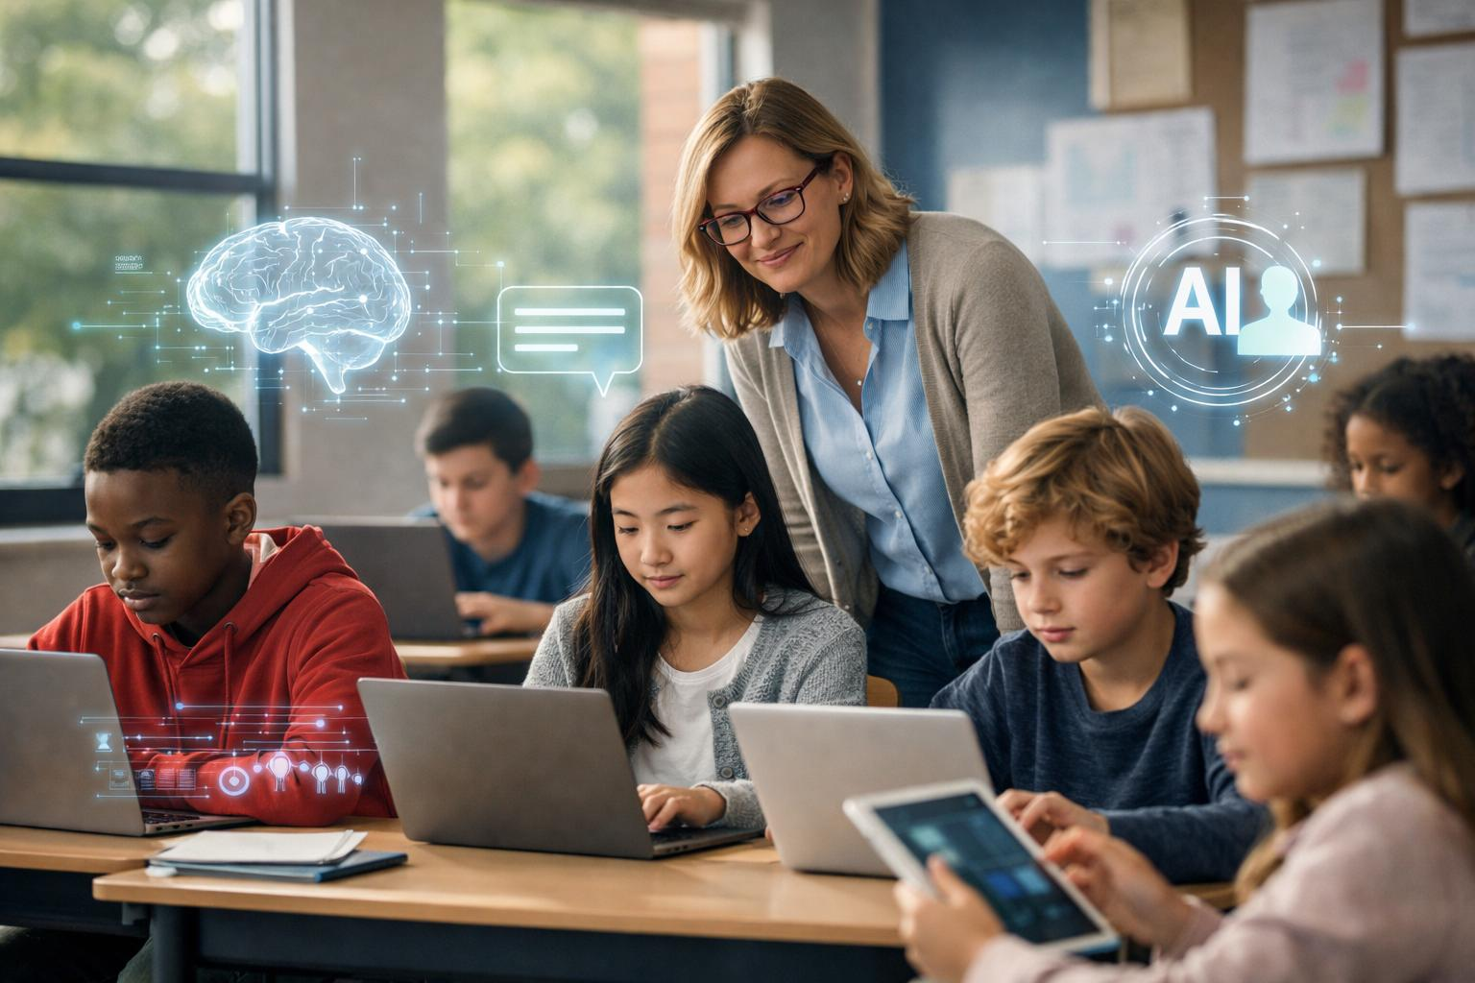
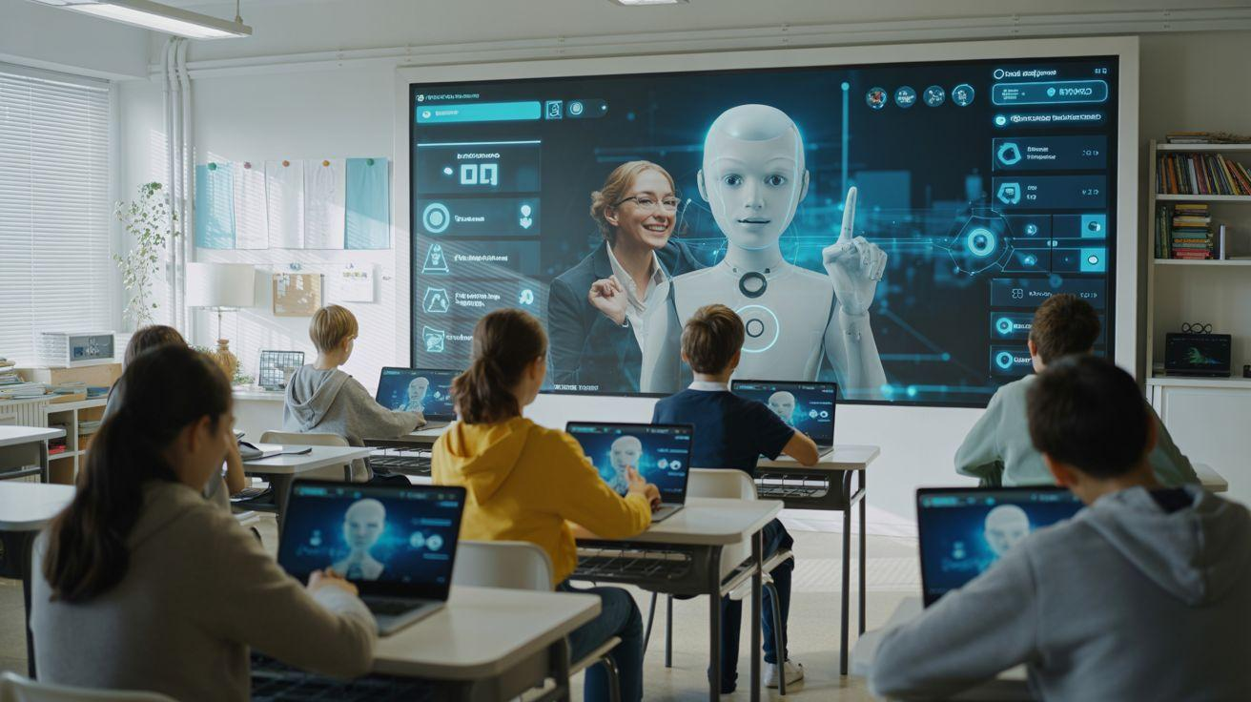
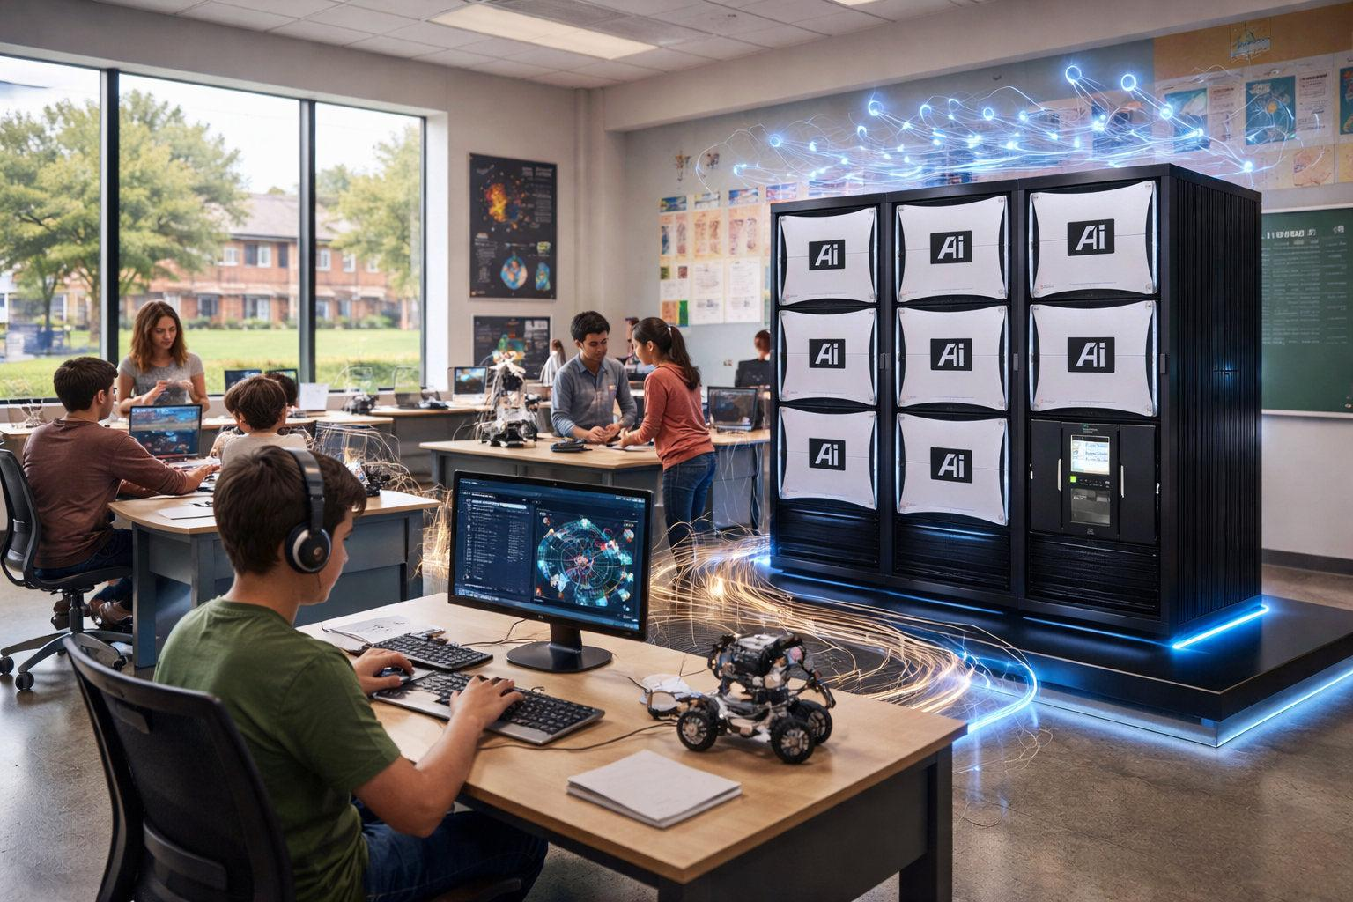


The solution is not to avoid AI. The solution is to design AI education correctly.
The biggest mistake schools can make is:
"Let AI teach everything."
The better approach is:
AI supports learning; humans control learning.
A successful AI education system needs several protections.

1. Prevent AI Dependency → Teach "AI-Assisted Thinking"

Problem
Students ask:
"AI, give me the answer."
They copy the result.

Solution
Change the role of AI.
Bad:
Student:
Solve this math problem.

AI:
Here is the answer.
Good:
Student:
Solve this math problem.

AI:
What approach would you try first?
Why do you think this formula applies?

(Student thinks)

AI:
Good. Now let's check your solution.
AI should act like a coach, not a shortcut.

2. Protect Critical Thinking → Use AI as a Debate Partner
Instead of AI always answering:
AI should ask questions.
Example:
Student:
"I think this historical event happened because of money."
AI:
"That is one possible explanation. What evidence supports it? Can you find another cause?"
Benefits:
Students practice:
- reasoning
- analysis
- argument building

3. Keep Teachers in Control (Human-in-the-Loop)
AI should never independently decide:
- student ability
- promotion
- punishment
- career direction
Better architecture:
AI Analysis

|
↓

Teacher Reviews Result

|
↓

Human Decision
Example:
AI says:
"Student may need additional math support."
Teacher checks:
- family situation
- motivation
- classroom behavior
Then decides.

4. Protect Student Privacy
The best approach is:

Local AI / Private AI
Instead of:
Student Data
|
↓
External AI Company
Use:
Student Data
|
↓
School Private Server
|
↓
Local AI Model
Benefits:
- data stays inside school
- better privacy
- no dependence on external companies
Especially important for:
- government schools
- children's data
- rural schools

5. Reduce Wrong AI Answers → Use RAG Technology
A normal AI:
Question
↓
General AI knowledge
↓
Answer
Risk:
AI may hallucinate.

Better:
Question

↓

School Knowledge Database

- textbooks
- teacher materials
- past exams
- curriculum

↓

AI Answer
This is called:
RAG (Retrieval-Augmented Generation)
The AI answers based on trusted school information.

6. Preserve Creativity → Change Assignments
Old homework:
"Write an essay about pollution."
AI can do it.

New homework:
Step 1:
Student creates first idea

Step 2:
AI gives suggestions

Step 3:
Student improves

Step 4:
Student explains choices
Assessment focuses on:
- thinking process
- creativity
- explanation
Not only final answers.

7. Maintain Human Interaction
AI should not replace classrooms.
A good balance:
Education

40% AI Learning

40% Teacher Guidance

20% Group Activities
Students still need:
- teamwork
- discussion
- leadership
- communication

8. Prevent Cheating → Change Evaluation
Traditional exams become less effective.
Future assessment:

Project-based learning
Example:
Instead of:
"Explain programming."
Students build:
- website
- robot
- AI project

Oral explanation
Teacher asks:
"Why did you choose this method?"
AI cannot easily replace personal understanding.

9. Train Teachers
Teachers need AI literacy.
Training:

Level 1
Basic usage:
- AI lesson generation
- AI grading assistance

Level 2
Advanced:
- student analytics
- AI curriculum design

Level 3
Expert:
- AI education strategy

10. Build AI Safety Rules
Every smart school should have:

AI Usage Policy
Examples:
Students can use AI for:
✅ explanation
✅ brainstorming
✅ practice
✅ feedback
Students cannot:
❌ submit AI-generated homework directly
❌ hide AI usage

11. Build Backup Systems
A smart school should not completely depend on AI.
Architecture:
Smart School

|
----------------

AI Server

|
----------------

Traditional Materials

|
----------------

Human Teachers
If AI fails:
- teachers continue teaching
- students continue learning

12. Create AI Literacy Classes
Students should learn:
- how AI works
- AI limitations
- fact checking
- privacy
- responsible usage
Future students need:
"AI skills"
like previous generations needed:
"Computer skills."

Ideal Smart School AI Architecture
A mature system would look like:
Smart School AI

|
----------------------------------

AI Tutor Teacher AI Analytics

| | |

----------------------------------

Private Knowledge Base

----------------------------------

Textbooks
Exams
Teacher Answers
Student Records

----------------------------------

School Server

----------------------------------

Final Principle
The future education model should be:
Human | AI
Motivation | Information
Creativity | Practice
Judgment | Analysis
Emotional support | Personalization
Ethics | Automation
The winning model is not:
AI replaces teachers
but:
One teacher + AI can support hundreds of students with the quality of private tutoring.
For your smart school AI engine idea, these solutions should become the core design requirements:
- Local/private AI server
- RAG knowledge engine
- Teacher approval system
- Student analytics
- AI tutor with questioning ability
- Strong privacy and security layer
That architecture addresses almost all major disadvantages of AI-based education.

Q5: Teaching students how to program is essential?
A5:
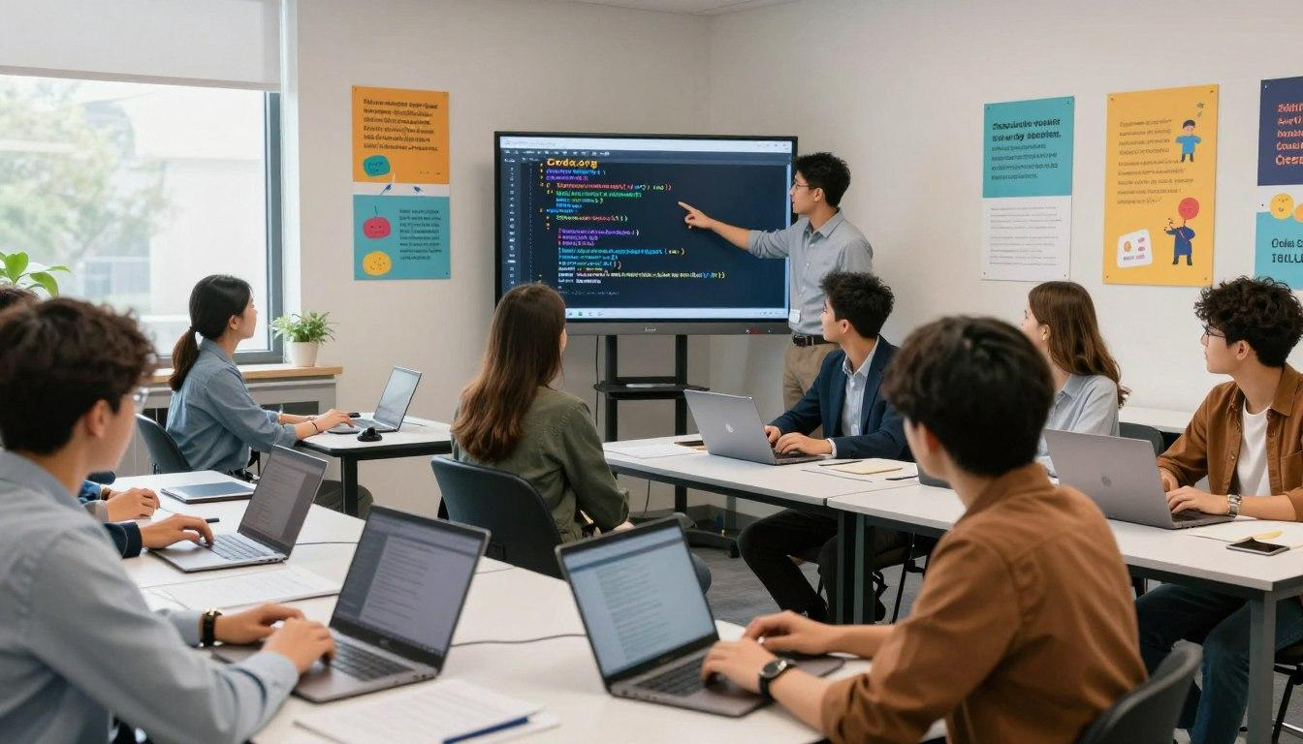
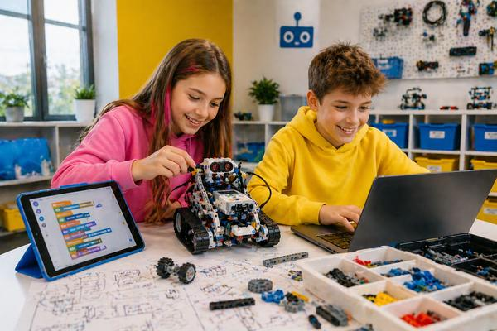
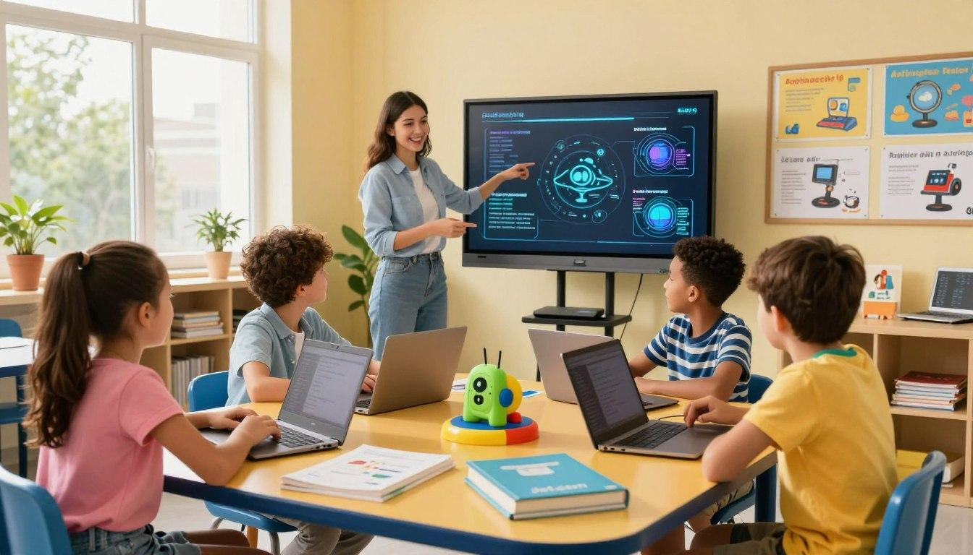
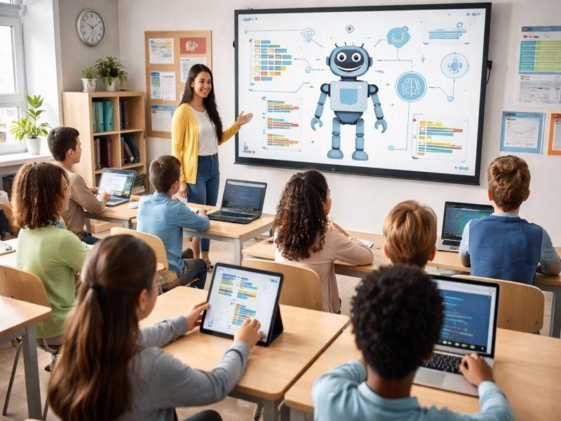
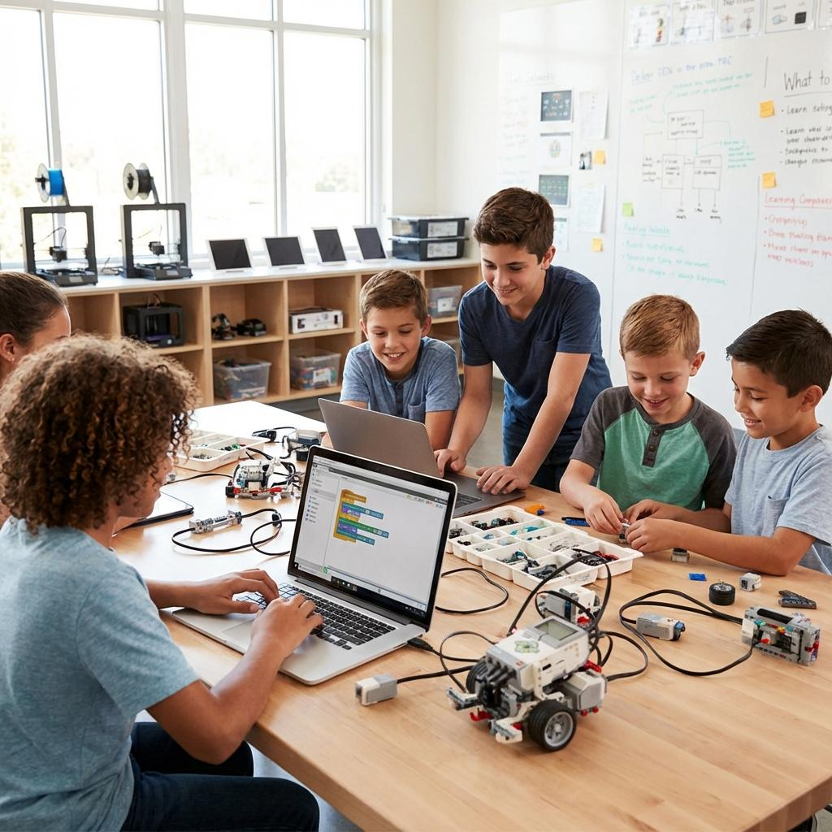
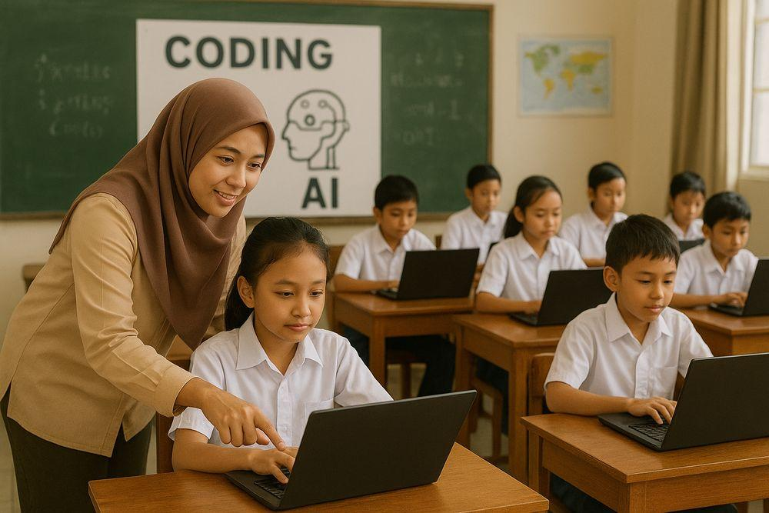
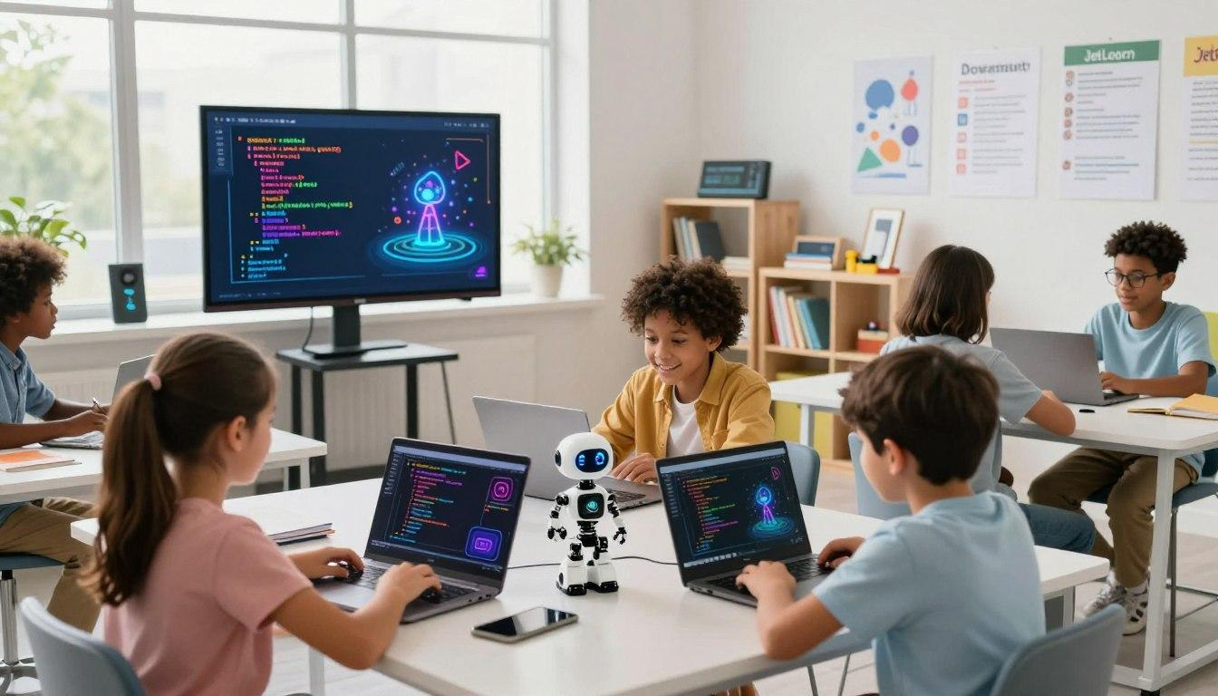
Yes, teaching students programming is important for the future, but the reason is changing.
In the past, the goal was:
"Learn programming so you can become a software engineer."
In the future, the goal is broader:
"Learn programming so you can understand, control, and create with technology."
Not every student needs to become a professional programmer, but computational thinking and AI literacy will likely become basic skills, similar to reading, writing, and mathematics.

1. Programming Teaches Problem-Solving
The biggest value of programming is not writing code.
It teaches students how to think.
Programming requires:
Problem
↓
Break into smaller parts
↓
Create logical steps
↓
Test solution
↓
Fix mistakes
This skill applies to:
- science
- business
- engineering
- research
- daily decisions
Example:
A student learns:
"How do I make a robot move?"
They learn:
- analyze the problem
- design a solution
- test
- improve
This is computational thinking.

2. AI Makes Programming More Important, Not Less
Some people ask:
"If AI can write code, why should students learn programming?"
The answer:
AI can generate code, but humans still need to:
- define the problem
- understand the output
- check mistakes
- design systems
- make decisions
A person who understands programming can use AI much more effectively.
Example:
Beginner:
"AI, make me an app."
Advanced user:
"Create a React application with authentication,
PostgreSQL database, REST API,
role-based permissions, and testing."
The second person gets much better results because they understand software concepts.

3. Programming Becomes a Universal Creation Tool
In the future, many jobs will use programming.
Examples:

Doctor
Uses programming for:
- medical data analysis
- AI diagnosis tools

Scientist
Uses programming for:
- simulations
- experiments

Businessperson
Uses programming for:
- automation
- data analysis

Teacher
Uses programming for:
- creating educational tools
- analyzing students

4. Children Can Learn at Different Levels
Not every student needs the same depth.

Age 5–8
Focus:
- logical thinking
- algorithms
- simple games
Tools:
- Scratch
- Blockly
Example:
"Make a character move when you press a button."

Age 9–12
Focus:
- basic programming concepts
Learn:
- variables
- loops
- conditions
- functions
Languages:
- Python
- JavaScript

Age 13–16
Focus:
- real projects
Examples:
- websites
- mobile apps
- robotics
- AI projects

Age 16+
Advanced:
- software engineering
- machine learning
- cybersecurity
- data science

5. Programming Helps Students Understand AI
Future citizens will interact with AI every day.
Programming teaches:

How AI works
Students understand:
- data
- algorithms
- models
- limitations
They become users who can evaluate AI instead of blindly trusting it.

6. Programming Builds Creativity
Many people think programming is only mathematics.
Actually:
Programming is a creative activity.
Students can create:
- games
- websites
- robots
- animations
- AI applications
Example:
A student has an idea:
"I want an app that helps students study English."
Programming turns the idea into reality.

7. But Traditional Programming Education Must Change
Old programming education:
Memorize syntax
↓
Write small programs
↓
Pass exam
This is becoming less useful.
Future programming education:
Real problem
↓
Design solution
↓
Use AI tools
↓
Build project
↓
Explain decisions
Students should learn:
- programming concepts
- system design
- debugging
- AI-assisted development

8. What Programming Languages Should Schools Teach?
A possible modern path:
Age | Language | Purpose
6–10 | Scratch | Logic and creativity
10–14 | Python | Easy programming + AI foundation
13–18 | JavaScript | Web development
15+ | SQL | Data understanding
16+ | C/C++ | Computer fundamentals
16+ | AI tools | Modern development

9. The Future Student Profile
A strong future student may look like:
Basic Math
+
English Communication
+
AI Literacy
+
Programming
+
Critical Thinking
+
Creativity
+
Collaboration
Programming becomes one part of a larger skill set.

10. For Smart Schools, Programming Education Should Include AI
A modern curriculum could be:
Year 1:
Computational thinking

Year 2:
Python basics

Year 3:
Web development

Year 4:
Database + APIs

Year 5:
AI application development

Year 6:
Real-world projects
Students could build:
- AI assistants
- school apps
- robots
- data analysis systems

Final Answer
Yes, programming education is essential for the future, but not because every student must become a programmer.
The real goal is:
"Create students who can understand technology, solve problems, and use AI as a powerful tool."
For a smart school AI system, programming should not be just another subject. It should become a foundation skill connected with:
- AI
- robotics
- mathematics
- science
- entrepreneurship
- real-world projects
The schools that teach students how to create with technology, rather than only consume technology, will have a major advantage in the future.

Q6: What programming languages are essential?
A6:
For future education, the goal should not be to teach students many programming languages. The goal is to teach the right languages in the right order.
A good modern curriculum should focus on languages that build:
- Computational thinking
- AI skills
- Web and app development
- Data skills
- Understanding how computers work
A recommended path is:

1. Scratch (Age 6–10) — Programming Thinking
Scratch
Purpose:
- logic
- algorithms
- creativity
- problem solving
Students learn:
- loops
- conditions
- events
- sequences
Example:
"Make a character move when a key is pressed."
They learn programming concepts without worrying about syntax.
Essential for young beginners.

2. Python (Age 10+) — The Most Important First Real Language
Python
Python is probably the most important language for future education.
Why?
Because it is used in:

AI
- machine learning
- deep learning
- LLM applications

Data science
- statistics
- visualization
- analytics

Automation
- scripts
- workflows

Science
- simulations
- research
Example:
student_score = 90

if student_score >= 80:
print("Good result")
Students immediately understand logic.
Recommended starting language for serious programming.

3. JavaScript / TypeScript (Age 12+) — The Language of the Internet
JavaScript
TypeScript
Almost every student will use the internet.
JavaScript teaches:
- websites
- interactive applications
- browser programming
Students can create:
- websites
- dashboards
- online tools
Example:
button.onclick = function() {
alert("Hello Student");
}
TypeScript adds:
- safer code
- professional software development skills
For modern software engineering:
JavaScript + TypeScript are extremely valuable.

4. SQL (Age 13+) — Understanding Data
SQL
Many students ignore databases, but data is the foundation of AI.
SQL teaches:
- storing information
- searching data
- analyzing information
Example:
SELECT *
FROM students
WHERE score > 90;
Useful for:
- AI systems
- business
- science
- education analytics

5. HTML + CSS (Age 10+) — Digital Creation
HTML
CSS
Technically they are not programming languages, but students should learn them.
They teach:
- webpage structure
- design
- user interface
Students can quickly create visible results.

6. C / C++ (Age 15+) — Computer Fundamentals
C++
Important for understanding:
- memory
- operating systems
- hardware
- robotics
- game engines
Used in:
- embedded systems
- robots
- high-performance software
Example:
Robotics:
C++
↓
Microcontroller
↓
Robot movement
Not necessary for every student, but valuable for advanced students.

7. Java (Age 15+) — Enterprise and Android
Java
Still widely used in:
- enterprise systems
- Android development
- large organizations
It teaches:
- object-oriented programming
- software architecture

8. Swift / Kotlin — Mobile Development
For students interested in mobile apps:

iOS
Swift

Android
Kotlin
Students can build:
- iPhone apps
- Android apps

9. R — Statistics and Research
R
Important for:
- universities
- scientific research
- statistics
Less important for general students compared with Python.

10. AI Programming Skills (Not a Language, but Essential)
Future students should learn:

AI APIs
Examples:
- using AI models
- building AI applications

Prompt engineering
- asking AI correctly
- evaluating AI output

Machine learning concepts
- datasets
- models
- training
- evaluation

Recommended Smart School Curriculum
A modern education roadmap:
Age | Skills
6–8 | Scratch + logic games
9–11 | Scratch + Python basics
12–13 | Python + HTML/CSS
13–15 | JavaScript + SQL
15–16 | TypeScript + software projects
16–18 | AI + data science + advanced programming
University | Specialization

If I Had to Choose Only 5
For the next 20 years, I would choose:

1. Python ⭐⭐⭐⭐⭐
AI, data, automation

2. JavaScript / TypeScript ⭐⭐⭐⭐⭐
Internet, applications, software

3. SQL ⭐⭐⭐⭐⭐
Data and AI foundation

4. C++ ⭐⭐⭐⭐
Computer understanding, robotics

5. Scratch ⭐⭐⭐⭐
Children's programming foundation

For a Smart School AI Project
If you are designing a future-oriented school curriculum, I would make the core:
Programming Foundation
|
|
Scratch
|
Python
|
JavaScript + TypeScript
|
SQL + Data
|
AI Development
|
Robotics / Advanced Computing
This matches where education is moving: students become creators of technology, not only users of technology.

